African Nationalism/ Apartheid in South Africa Quiz.

1. Which statement best describes the political situation in Africa after World War II?
- increased nationalism led to independence for many African nations
- France and West Germany sought to establish colonies in Africa
- European nations increased their control over their African colonies
- the United Nations opposed the idea of self-determination for African nations

2.Which conclusion is best supported by this cartoon?
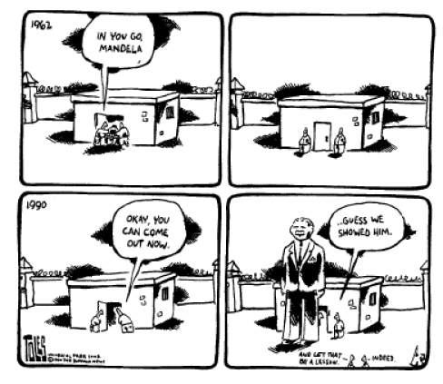
- Imprisonment of political dissidents rarely ends opposition to the government.
- The United Nations supports punishment for acts of civil disobedience.
- Better media coverage would prevent the imprisonment of protesters.
- Mistreatment of political prisoners often results in their acceptance of government policies

3.In the Republic of South Africa, the slogans “Freedom in Our Lifetime” and “New South Africa” changed from promises to reality after
- Frederik W. de Klerk took over the radical white police force
- Untied Nations troops occupied the Transvaal
- Nelson Mandela was elected President
- the majority of white South Africans returned to Europe

4.Which factor most limited the development of African nationalism?
- European support of an educational system based on local traditions and language
- the prior experience of Africans with economic self-sufficiency
- political boundaries imposed by Europeans that had little relationship to African tribal boundaries
- the European practice of making decisions based on local customs
5. One way in which Kwame Nkurmah, Jomo Kenyatta, and Kenneth Kaunda are similar is that they all
- supported the United Nations military action in the Persian Gulf War
- played a major role in independence movements in Africa
- rejected financial aid from the World Bank
- opposed the Pan-African movement

