Classical Civilization.
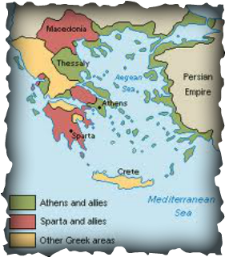
- Use the map and your knowledge of social studies to answer the following question.
How did the geography of Greece affect its economic activity and political divisions?
- Greece was unable to unite into a large empire and instead formed small city-states.
- Greece contained a large amount of fertile land and therefore relied heavily on agriculture.
- Greece was extremely isolated and therefore unable to trade with others.
- Greece united to form a large empire.

- Which ancient civilization established the basis of western democracy?
- Phoenician
- Egyptian
- Sumerian
- Greek

- The political system of the Ancient Roman Empire was characterized by
- a strong central government
- rule by a coalition of emperors and religious leaders
- universal suffrage in national elections
- a strict adherence to constitutional principles

- The Ancient Greek city-state of Sparta
- was primarily concerned with the health of their people
- was a powerful military state
- granted universal suffrage to their people
- placed great emphasis on literature and the arts

- Which societal condition was basic to the development of Greek philosophy?
- rigid social classes
- emphasis on individualism
- religious uniformity
- mass education

- Alexander the Great’s conquests of Greece, Asia Minor, Egypt, and Persia led to the
- spread of Hellenic culture
- adoption of a feudal system
- establishment of representative democracy
- spread of Islamic culture throughout Europe
- A major impact of Ancient Greece and Rome on Western Civilization was that
- the Greeks and Romans succeeded in achieving a classless society, which was later copied in Western Europe
- Greek sculpture and Roman architecture were much admired and copied in the 18th and 19th centuries
- Greece and Rome transmitted Islamic philosophy to the areas they conquered
- Greek and Latin are still widely spoken in universities throughout the West

- A major contribution of the Roman empire to western society was the development of
- gunpowder
- the principles of feudalism
- monotheism
- an effective legal system

