Early Civilization
- One result of the Neolithic Revolution was
- an increase in the number of nomadic tribes.
- a reliance on hunting and gathering for food.
- the establishment of villages and the rise of governments.
- a decrease in trade between cultural groups.

- Use the diagram and your knowledge of social studies to answer the following question.
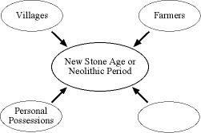
Which characteristic belongs in the empty circle?
- hunters and gatherers
- very small population
- cave paintings
- domestic animals

- One similarity in the Mesopotamian, Egyptian, ancient Indian (Harappan), and ancient Chinese civilizations was that they each developed
- democratic governments.
- monotheistic religions.
- irrigation systems.
- industrialized economies.

- The river valleys of the Tigris-Euprhates, the Nile, and the Indus were centers of civilization because they
- had rich deposits of iron ore and coal.
- were isolated from other cultural influences.
- were easy to defend from invasion.
- provided a means of transportation and irrigation.

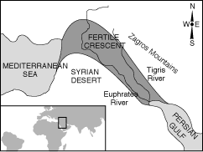
- Use the map and your knowledge of social studies to answer the following question.

Based on the map, the Fertile Crescent was land located
- east of the Zagros Mountains.
- along the Nile River.
- along the west coast of the Persian Gulf.
- between the Tigris and Euphrates rivers.

