Industrial Revolution Quiz
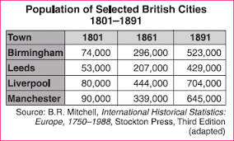
- Which event caused this population shift in Great Britain?
  - The bubonic plague
  - Immigration to the Americas
  - The Industrial Revolution
  - Rebellions in Ireland
- Which development caused the other three?
  - Increased rural to urban migration
  - Increased productivity of industrial workers
  - Introduction of the factory system
  - Unsafe working conditions
- “It was a town of red brick, or of brick that would have been red if the smoke and ashes had allowed it; but as matters stood it was a town of unnatural red and black like the painted face of a savage. It was a town of machinery and tall chimneys, out of which interminable serpents of smoke trailed themselves for ever and ever, and never got uncoiled. It had a black canal in it, and a river that ran purple with ill-smelling dye…”

Which problem of the Industrial Revolution is the subject of this passage?
  - Economic inequality
  - Urban pollution
  - Lack of child labor laws
  - Poor transportation systems

- A long-term effect of the Industrial Revolution was the
  - Increased availability of a large number of craftspeople
  - Development of labor reforms and labor unions
  - Failure of communities to provide schools
  - Disappearance of the middle class

