World War I Review Quiz,

Archduke Franz Ferdinand Assassinated!”
“Germany Declares War on Russia and France!”
“Peace Treaty Signed at Versailles!”
1.Which event is referred to in these headlines?
- Franco-Prussian War
- Crimean War
- World War I
- Cold War

2. A major cause of World War I was
- a decline in the policy of imperialism
- the existence of opposing alliances
- an increase in acts of aggression by England
- the spread of communism throughout Europe
3. The major impact of the Treaty of Versailles on Germany was that the treaty led to
- an era of peace and international good will in Germany
- a stable Germany that was both democratic and strong
- an increase in Germany’s desire to regain its power and prestige
- a leadership position for Germany in the League of Nations
“
4. What was the immediate cause of World War I in Europe?
  - Start of the civil war in Russia
  - Sinking of the British liner, Lusitania
  - Assassination of the heir to the throne of the Austro-Hungarian Empire
  - Attack on Poland by the German army
“The Allied…governments…affirm, and Germany accepts, the responsibility…for causing all the loss and damage to which the Allied…governments and their nationals have been subjected as a consequence of the war imposed on them by the aggression of Germany.”
5, What was a result of the provisions of this document?
  - Allied governments helped rebuild the German economy
  - Resentments about these provisions contributed to the growth of Nazism in Germany
  - The ideas in these provisions served as the basis for the European Union
  - The provisions became a blueprint for lasting peace in Germany

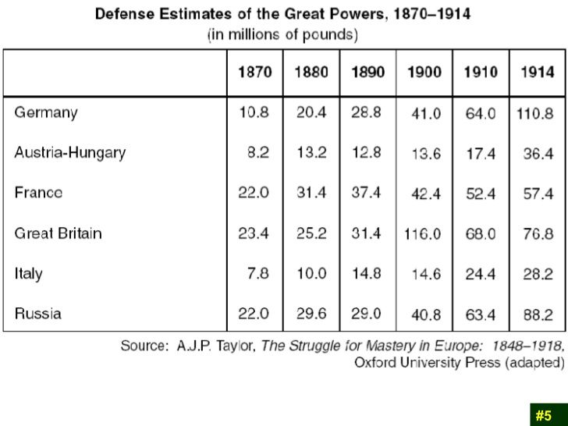
6.Which statement is best supported by the data contained in the table?
  - Austria-Hungary could not afford a large military expenditure in 1880.
  - France spent the greatest amount of money on defense in 1900.
  - Germany rapidly increased its military spending after 1890.
  - Great Britain attempted to prepare for a long ground war.

